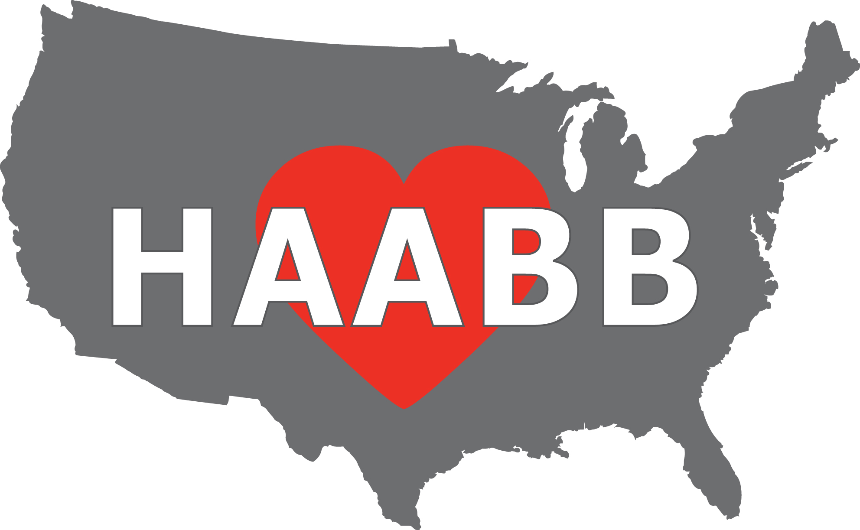

Heart of America
Association of Blood Banks

48th Annual Meeting
April 21 – April 22, 2015

PRELIMINARY
PROGRAM

Harrah’s Hotel
One Riverboat Drive
North Kansas City, MO
64116

Visit us at
www.HAABB.org

TUESDAY, APRIL 21, 2015

7:30 – 8:30 Registration located outside of meeting rooms

8:30 – 11:45 AM Session
- Case Study: Suspected Hemolytic Transfusion Reaction
With A Negative Antibody Screen
Christina Barron, ARC Missouri-Illinois Region
- Research in Sickle Cell Treatment
Dr. Flavia Costa, IntelligeneDx and KUMC
- Case Study
Julia Larson, University of Kansas Hospital
- IRL and BB/TS Assessments
Mary Kowalski, Community Blood Center
Sharon Rice, Saint Luke’s Hospital

11:45 – 1:15 Lunch and Opening of Vendor Exhibits

1:15 – 4:15 PM Session
- Nightmare On Main Street
Shay Jones, Community Blood Center
- Thromboelastography
Dr. Richard Gilroy, University of Kansas Hospital
- Case Study
Beth Jones, Saint Luke’s Hospital
- Transfusion Medicine and Ebola Virus Disease
Dr. Scott Koepsell, University of Nebraska Medical Center

4:15 – 6:00 Reception / Vendor Exhibits

WEDNESDAY, APRIL 22, 2015

7:30 – 8:30 Registration

8:30 – 11:30 AM Session
- Stroke Measures: Diagnosis, Treatments and Case Studies of Stroke Patients
Angela Hawkins, Saint Luke’s Hospital
- “O-ver There”: Blood Transfusion in World War One
Steve Pierce, retired
- Rapid Reversal of Anticoagulation
Dr. Fred Plapp, Saint Luke’s Hospital

11:30-1:00 Lunch and Vendor Exhibits

1:00 - 1:15 HAABB Annual Business Meeting

1:15 – 4:00 PM Session
- “U” Thought It Was Bad…
Gina Folk, Community Blood Center
- Pathogen Inactivation – Where Are We Now?
Dr. Eric Senaldi, New York Blood Center
- HUS/TTP…SOS!
Megan Kindle, North Kansas City Hospital
- Who Needs Rh Negative Blood and Rh Immunoglobulin?
Connie Westhoff, New York Blood Center

HOTEL RESERVATIONS
Harrah’s Hotel  One Riverboat Drive  North Kansas City, MO 64116  For reservations, call 800-HARRAHS (427-7247) before 3/30/15 to receive the applicable group rate of $99 per night. Use the HAABB group code: S04HBB5, group name HEART OF AMERICA ASSOCIATION OF BLOOD BANKS.  Harrah's North Kansas City offers the most exciting hotel and casino in the heart of America. It has over 392 luxurious rooms, mouthwatering restaurants, the best nightlife and live entertainment in town. Harrah’s dining options including Mike and Charlie’s Italian Restaurant, 810 Sport Zone, The Buffet at Harrah’s, The Range, and Corner Grill.  Other shopping centers and dining options include:  Briarcliff Village (6 miles): Trezo Mare and Piropos.  Zona Rosa (approx.12 miles): Bo Lings, Hereford House, Abuelo’s Mexican Food Embassy, 54th Street Grill and Bar, and Granite City Food and Brewery are a few of the more than 15 restaurants located here.  The Country Club Plaza (approx. 12 miles) The Plaza has over 40 restaurants including PF Chang’s, Kona Grill, Houston’s and McCormick & Schmick’s, Fiorella’s, and Jack Stack Barbeque.  Kansas City International airport is within 20 miles.  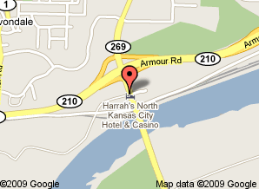  Directions:  From downtown Kansas City; take US-71 / I-29 north.  Exit at MO-210 Armour Road. Turn right onto Armour Road.  Take the Chouteau Tfwy MO-269 ramp and go south on Chouteau to Riverboat Drive. Follow the signs to Harrah’s.  From St Louis, take I-70 west to I-435. Go north on I-435.  Exit at MO-210 Armour Road. Go west on MO-210.  Take the Chouteau Tfwy MO-269 ramp and go south on Chouteau to Riverboat Drive. Follow the signs to Harrah’s | (
2015 HAABB ANNUAL MEETING REGISTRATION

REGISTRATION INFORMATION

There are 4 sessions available: Tuesday AM, Tuesday PM, Wednesday AM and Wednesday PM. The costs associated with each type of registration are as follows:

Individual: $60 After 4/7/15, each session price will increase to $65

Institutional: $55 per attendee The Institutional Membership cost is an additional $30.
After 4/7/15, each session price will increase to $60

Student: $20 After 4/7/15, each session price will increase to $25
______________________________________________________________________________________________________

Methods of Registration:
Mail—Complete and mail the registration form including payment to the following address. Make check payable to HAABB. Diana Moroney, HAABB Treasurer
844 Evergreen Forest Drive
Saint Peters, MO 63376

Online—Register online at www.haabb.org to make payment via credit card. ______________________________________________________________________________________________________

Registration Form Instructions: The registration form is divided into two sections: individual/student attendees and institutions requesting to send multiple attendees. Below describes each section.

Individual/Student Attendees Section: This section is for the individual or student seeking to attend the meeting. For the individual, HAABB individual membership is included in the price of the sessions. By attending, membership is obtained. Membership will begin upon receipt of payment and will expire April 12, 2016. This section should also be used for students wishing to attend the meeting at a discounted student session rate.

Institutional Attendees Section: This section is for institutions seeking to have multiple employees attend the meeting at a discounted session rate. HAABB institutional membership cost is $30. There is no limit to the number of employees that may attend when an institutional membership is obtained. The session fee must be paid per person per session attended. Membership will begin upon receipt of payment and will expire April 12, 2016.

NOTE: If you need to cancel your registration, please send an email to Diana Moroney, HAABB Treasurer, at Diana.moroney@redcross.org, by April 14, 2015 to receive a full refund. After April 14, 2015, the registration fee is non-refundable.

ANNUAL MEETING DETAILS

Lunch:
All registrants are invited to enjoy lunch compliments of the HAABB Board of Directors! Lunch will be provided to the registrants on the day of the session(s) attended. If you desire a VEGETARIAN lunch, please check the box on the registration form.

Evening Reception:
Registrants attending the Tuesday PM session are invited to the evening reception immediately following the final speaker for that day. Food and beverage will be provided as attendees have a chance to interact with peers, exhibitors, and members of the HAABB Board of Directors.

Parking: Parking is Free.

2015 HAABB ANNUAL MEETING REGISTRATION

INDIVIDUAL or STUDENT MEMBERSHIP ATTENDEE INFORMATION

Name: ______________________________________________________

Institution Name: ______________________________________________________

Institution Address: ______________________________________________________

Credentials: ______________________________________________________

Email & Phone: ______________________________________________________

Check the sessions you will be attending: □ Tues AM □ Tues PM □ Wed AM □ Wed PM
VEGETARIAN LUNCH □ (please check if needed)

INDIVIDUAL: Each session price is $60. The membership cost is included in the session prices. After 4/7/15, each session price will increase to $65.

STUDENT: Each session price is $20. After 4/7/15, each session price will increase to $25.

INDIVIDUAL: Total Cost = $60 x # of Sessions = $________________
STUDENT: Total Cost = $20 x # of Sessions = $________________

INSTITUTIONAL MEMBERSHIP ATTENDEE INFORMATION

Institution Name: ______________________________________________________

Institution Address: ______________________________________________________

Contact Person: ______________________________________________________

Email & Phone: ______________________________________________________

In the space provided, please include the attendee names, credentials, and which sessions will be attended. If additional space is needed, please attach a separate sheet. There is no limit to the number of attendees that can register when an institutional membership is obtained. Four sessions are available. Each session price is $55 per attendee. The institutional membership cost is an additional $30. After 4/7/15, each session price will
increase to $60.

Attendee Name Credentials Tues AM Tues PM Wed AM Wed PM

1. ______________________________________ □ □ □ □
2. ______________________________________ □ □ □ □
3. ______________________________________ □ □ □ □
4. ______________________________________ □ □ □ □
5. ______________________________________ □ □ □ □
Please indicate if any of the attendees requires a vegetarian lunch (* by the name)
Cost of Institutional Membership = $30
Cost of Sessions = $55 x # of Sessions = $____________

Total Cost = $30 + Cost of Sessions = $___________

