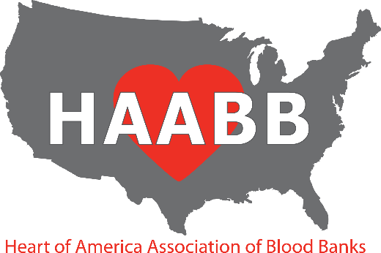

2024 Fall Meeting

**September 18, 2024**

PRELIMINARY PROGRAM

***AM Session***

07:30 – 08:30 **Registration**

08:30 – 08:45 ● **Welcome—Carrie Easley, HAABB President**

08:45 – 10:00 ● **Case Study: Where’s the Back Type – Investigating an ABO Discrepancy**

Will Karstens, MLT (ASCP) -- University Hospital, Columbia Missouri

● **Pre-Hospital Transfusion**

Daniela Hermelin, MD -- Chief Medical Officer, ImpactLife

10:00 – 10:30 **Vendor Exhibits (Break)**

10:30 – 11:45 ● **Case Study: OM-G**

Christina Barron, MLS (ASCP) SBB – IRL Divisional Director, American Red Cross

* **MLS Career Advancement; Keeping Staff Engaged**

Brenna Ildza, MHS, MLS (ASCP) SH, PBT -- MLS Program Director, Saint. Luke’s

Hospital

11:45-1:00 **Lunch**

***PM Session***

1:00 – 2:15 **● Case Study: Take My Breath Away: The Case of Mrs. Blue**

Mary Signaigo, MLS (ASCP) – Clinical Lab Educator, Mercy Hospital St. Louis

● **Intercept Fibrinogen Concentrate**

Cindy Ingold, MLS (ASCP) SBB – Manager, Transfusion Medicine/HLA, Barnes-Jewish Hospital

2:15 – 2:45 **Vendor Exhibits (Break)**

2:45– 4:00 ● **Case Study: Allo or Auto? Real World Application of Blood Group Genomics**

**Lynsi Rahorst, MHPE, MLS (ASCP) SBBCM – Manager, Education & Training, New York Blood Center Enterprises**

* **Exploring the Evolution of the Biotherapies Revolution**

Suzanne Thibodeaux, MD, PhD – Associate Professor, Washington University School of Medicine

Location:

Pear Tree Inn by Drury

# 2211 Market Street- near Union Station

# St. Louis, MO 63103

**HAABB 2024 Fall Meeting Registration Information**

**REGISTRATION INFORMATION**

There are 2 sessions available: Wednesday AM, Wednesday PM. The costs associated with each type of registration are as follows:

Individual: $65 per session After **9/10/2024**, each session price will increase to $70

Institutional: $60 per session The Institutional Membership cost is an additional $35.

After **9/10/2024**, each session price will increase to $65

CLS Student: $25 per session After **9/10/2024**, each session price will increase to $30

Resident: $50 per session After **9/10/2024**, each session price will increase to $55

______________________________________________________________________________________________________

**METHODS OF REGISTRATION:**

**Mail—**Complete and mail the registration form including payment to the following address. Make check payable to HAABB. **Brian Easley, HAABB Treasurer**

5402 NW 93rd St.

Kansas City MO 64154

**Online**—Register online at [www.haabb.org](http://www.haabb.org) to make payment via credit card. ______________________________________________________________________________________________________

**REGISTRATION FORM INSTRUCTIONS:**

The registration form is divided into two sections: Individual/Student/Resident attendees and Institutions requesting to send multiple attendees. Below describes each section.

**Individual/Student/Resident Attendees Section:** This section is for the individual or student seeking to attend the meeting. For the individual, HAABB individual membership is included in the price of the sessions. By attending, membership is obtained. Membership will begin upon receipt of payment and will expire April 1, 2025. This section should also be used for CLS students and Residents wishing to attend the meeting at a discounted student session rate.

**Institutional Attendees Section:** This section is for institutions seeking to have multiple employees attend the meeting at a discounted session rate. HAABB institutional membership cost is $35. There is no limit to the number of employees that may attend when an institutional membership is obtained. The session fee must be paid per person per session attended. Membership will begin upon receipt of payment and will expire April 1, 2025.

**NOTE:** If you need to cancel your registration, please send an email to Brian Easley, HAABB Treasurer, at [**beasley@saint-lukes.org**](mailto:beasley@saint-lukes.org), by September 11, 2024, to receive a full refund. **After September 11, 2024, the registration fee is non-refundable.**

______________________________________________________________________________________________________

**MEETING DETAILS:**

**Lunch**:

All registrants are invited to enjoy lunch compliments of the HAABB Board of Directors! **If you desire a VEGETARIAN lunch, please check the box on the registration form.**

**Parking:** Parking is Free. Attendees should park in the upper level of the hotel’s parking garage. The entrance is located off 23rd Street.

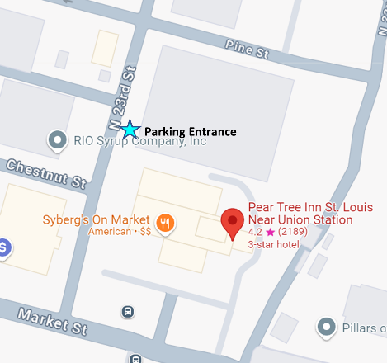

**HAABB 2024 Fall Meeting Registration Form**

(Please, see form instructions prior to completing)

**INDIVIDUAL / STUDENT / RESIDENT ATTENDEE INFORMATION**

**Attendee Name: __________________________________ Institution: ________________________________**

**Institution Address: ___________________________________________________________________________**

**Email*: __________________________________ Phone: ___________________________________________**

**\*Email address provided will be used by HAABB for communication regarding meetings and may be shared with vendor exhibitors.**

Check the sessions you will be attending:  **Wed AM**  **Wed PM**

**VEGETARIAN LUNCH**  **(please check if needed)**

**INDIVIDUAL: Total Cost = $65 ($70 after 9/10/2024) x # of Sessions = $________________**

**STUDENT: Total Cost = $25 ($30 after 9/10/2024) x # of Sessions = $________________**

**RESIDENT: Total Cost = $50 ($55 after 9/10/2024) x # of Sessions = $________________**

**INSTITUTIONAL MEMBERSHIP ATTENDEE INFORMATION**

**Institution Name: _________________________ Contact Person _______________________________________**

**Institution Address: ___________________________________________________________________________**

**Email*: ____________________________________ Phone: ________________________________________**

**\*Email address provided will be used by HAABB for communication regarding meetings and may be shared with vendor exhibitors.**

In the space provided, please include the attendee names, credentials, and which sessions will be attended. If additional space is needed, please attach a separate sheet. There is no limit to the number of attendees that can register when an institutional membership is obtained. Two sessions are available. Each session price is $60 per attendee. The institutional membership cost is an additional $35. **After 9/10/2024, each session price will**

**increase to $65**.

**Attendee Name Credentials Wed AM Wed PM**

**1. ___________________________________________**

**2. ___________________________________________**

**3. ___________________________________________**

**4. ___________________________________________**

**5. ___________________________________________**

***Please indicate if any of the attendees requires a vegetarian lunch (* by the name)***

Cost of Institutional Membership = $35

Cost of Sessions = $60 (**$65 after 9/10/2024**) x # of Sessions = $____________

**Total Cost = $35 + Cost of Sessions = $___________**

**HOTEL RESERVATIONS**

Pear Tree Inn near Union Station

2211 Market Street

St. Louis, MO 63103

(314) 241-3200

<https://www.druryhotels.com>

Please make your reservations by **August 30, 2024** to receive your group rate.  Reservations made after this date will be subject to prevailing rates and availability.   Reservations may also be made by calling **1-800-325-0720** and referring to your group number **10123043.**

At Drury Hotels, we know you have enough to worry about when traveling. In addition to the great rate, our generous amenities will brighten your group’s day and make your journey easier.

* **Complimentary Hot Breakfast** - Enjoy scrambled eggs, oatmeal, fresh fruit, potatoes, pastries, the all-important coffee and more.  Hot, fresh, and, best of all, free. Free hot breakfast is served daily from 6-9:30 a.m. on weekdays and 7-10 a.m. on weekends.
* **Complimentary Evening Drinks and Snacks\*** - Join us from 5:30 p.m. – 7:00 p.m. every evening to enjoy complimentary snacks and cold beverages at our 5:30 Kickback®.  The Hotel features a rotating menu of snacks, beer, wine, mixed drinks and soft drinks.
* **Complimentary Wi-Fi Throughout the Hotel** - Get the score, check social networks or email family members in the hotel!
* **On-Site Facilities** - Take advantage of the business center, fitness center or pool while away from home.  Print boarding passes, finish a presentation or check e-mail in the Hotel’s business centers.