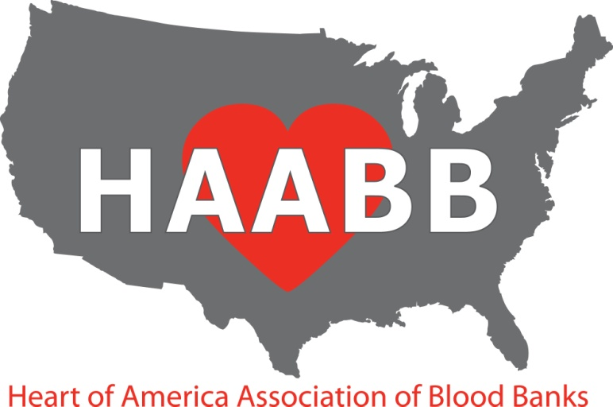

2015 Fall Meeting
October 6, 2015

PRELIMINARY PROGRAM

07:30 – 08:40 Registration and Breakfast (served from 7:30-8:30)

AM Session
08:40 – 08:45 ● Welcome—Jennifer Jung, HAABB President

08:45 – 10:00 ● Case Study: T-activation in the Newborn
Christina Barron, American Red Cross Blood Services, St. Louis, MO
Dr. Sarah Hackman, University of Missouri, Columbia, MO
● New Therapeutic Approaches to Treat Sickle Cell Disease
Dr. Flavia Costa, IntelligeneDx, Olathe, KS

10:00 – 10:30 Vendor Exhibits (Break)

10:30 – 11:45 ● Case Study: Mixed Up in the Blood Bank
Julia Larson, University of Kansas Hospital, Kansas City, KS
Where’s the Caffeine? IRL and BB/TS Assessments
Mary Kowalski, Community Blood Center, Kansas City, MO
Sharon Rice, Saint Luke’s Hospital, Kansas City, MO

11:45 – 1:00 Vendor Exhibits (Lunch provided)

PM Session
1:00 – 2:15 ● Case Study: “Unusual Suspects”
Beth Jones, Saint Luke’s Hospital, Kansas City, MO
● Thromboelastography
Dr. Jody Olson, University of Kansas Hospital, Kansas City, KS

2:15 – 2:45 Vendor Exhibits (Break)

2:45– 4:00 ● Case Study: Antibodies Are Not Always What they Seem…
Lindsay Peters, Mississippi Valley Regional Blood Center, St. Louis, MO
● Pathogen Inactivation
Dr. Angie Muniz, American Red Cross Blood Services, St. Louis, MO

Drury Inn & Suites near Forest Park

2111 Sulphur Avenue

St. Louis, MO 63139

Telephone: (314) 646-0770

Reservations must be made by September 3, 2015 to receive the discounted rate of $106. Reservations made after this date will be subject to prevailing rate and availability.

Make reservations by phone 1-800-325-0720 and refer to the group number of 2247108 or use the link below:

http://www.druryhotels.com/Reservations.aspx?groupno=2247108

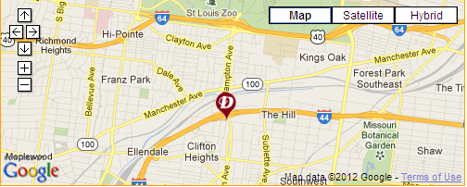

Directions:  Traveling East On I-44:  Take Exit #286  Turn Right On Hampton Ave  Turn Right On Wilson Ave  Turn Left On Sulphur Ave | Traveling West On I-44:  Take Exit #286  Turn Left On Hampton Ave  Turn Right On Wilson Ave  Turn Left On Sulphur Ave
The Extra’s Aren’t Extra at Drury Hotels! In addition to the great rate, here are some of the amenities our group will enjoy:

FREE HOT QUIKSTART ® Breakfast – At Drury, “hot” means Belgian waffles, scrambled
eggs, biscuits & gravy, sausage and more.

FREE 5:30 KICKBACK® - From 5:30-7:00 pm each evening, kick back, relax and enjoy a rotating menu of free hot food and cold beverages.

FREE Free Long Distance - One hour every room every night.

FREE Wireless Internet Access – High speed Internet in all rooms and the lobby.

FREE Soda and Popcorn – From 3:00 pm to 10:00 pm every night in the lobby.

Plus much more!!
HAABB 2014 Fall Meeting Registration Information

Registration Information:

There are two sessions available: Tuesday AM and Tuesday PM. The costs associated with each session
are as follows:

Individual: $60 After 09/22/2015, each session price will increase to $65.

Institutional: $55 per attendee Institutional membership cost is an additional $30.
After 09/22/2015, each session price will increase to $60.

Student: $20 After 09/22/2015, each session price will increase to $25.

Note: If you need to cancel your registration, please send an email to Diana Moroney, HAABB Treasurer, Diana.Moroney@redcross.org by 09/29/2015 to receive a full refund. After 09/29/2015, the registration fee is non-refundable.

Methods of Registration:

Mail: Complete and mail the registration form along with payment to the following address:

Diana Moroney
844 Evergreen Forest Drive
Saint Peters, Mo 63376

Make checks payable to HAABB.

Online: Go to the HAABB web page www.haabb.org to enter your registration information. You will be directed
to a PayPal page to make payment via credit card.
Registration Form Instructions:

The form is divided into three sections: individual attendee, institutions requesting to send multiple attendees, and student attendee. Below describes each section.

Individual Attendee Section:
This section is for the individual seeking to attend the meeting. HAABB individual membership is
included in the price of the sessions. Membership will begin upon receipt of payment and will expire
April 1, 2016.

Institutional Attendee Section:
This section is for institutions seeking to have multiple employees attend at a discounted session rate.
HAABB institutional membership cost is $30. There is no limit to the number of employees that may
attend when an institutional membership is obtained. Session fee must be paid for each session
attendance. Membership will begin upon receipt of payment and will expire April 1, 2016.

Student Attendee Section:
This section is for current MLS or MLT students wishing to attend the meeting. There is no
membership required to take advantage of the discounted session rate.

HAABB 2015 Fall Meeting Registration Form
(Please, see form instructions prior to completing)

Individual Attendee

Name: ______________________________________________________

Institution: ______________________________________________________

Credentials: ______________________________________________________

Email: ______________________________________________________

Session(s) attending: □ Tues AM □ Tues PM

Total Cost ($60* x # of sessions) = _____________ (*After 09/22/15, session prices increase to $65)
.

Institutional Attendee

Institution Name: ____________________________________________________________________

Institution Contact: _______________________________ Contact e-mail: ________________________

Name: Credentials Email Session(s) attending:

1. _________________________________________________________________ □ Tues AM □ Tues PM

2. _________________________________________________________________ □ Tues AM □ Tues PM

3. _________________________________________________________________ □ Tues AM □ Tues PM

4. _________________________________________________________________ □ Tues AM □ Tues PM

5. _________________________________________________________________ □ Tues AM □ Tues PM

Total Cost ($55* x # of sessions) + $30 = __________ (*After 09/22/15, session prices increase to $60.)

Student Attendee

Name: ______________________________________________________

Institution: ______________________________________________________

Email: ______________________________________________________

Session(s) attending: □ Tues AM □ Tues PM

Total Cost ($20* x # of sessions) = _____________ (*After 09/22/15, session prices increase to $25.)

