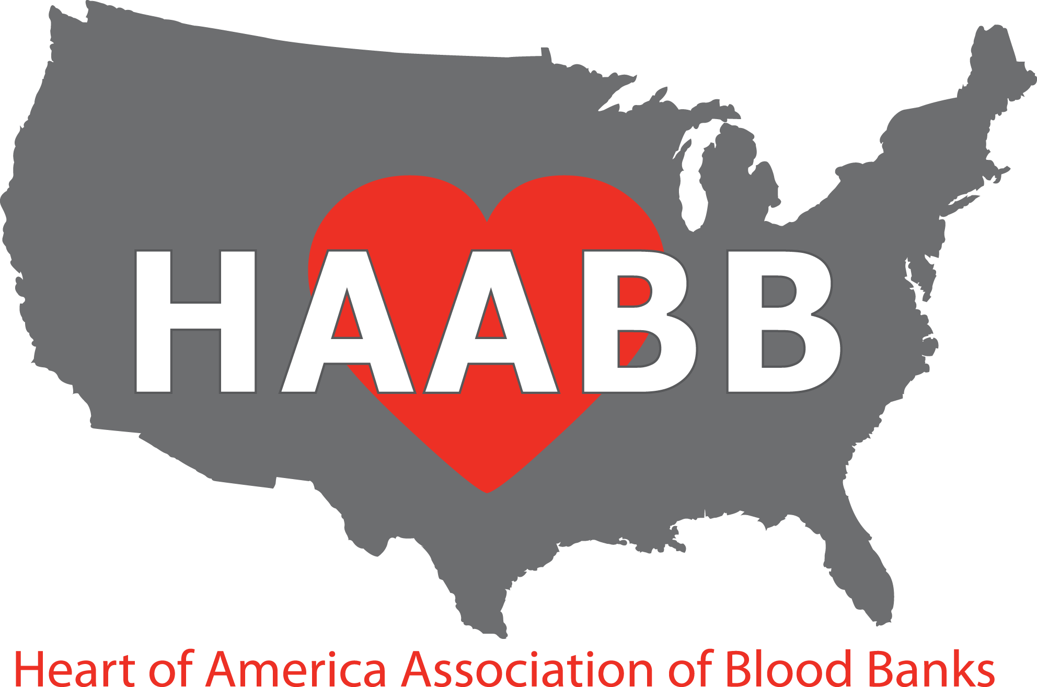

 Fall Meeting
September 13, 2017

PRELIMINARY PROGRAM

AM Session

07:30 – 08:40 Registration and Breakfast (served 7:30 – 8:30)

08:40 – 08:45 Welcome — Charles McDonald, HAABB President

08:45 – 10:00
- Case Study - Management of Immune Thrombocytopenia in an Unplanned Pregnancy
Jennifer Meyer, MLS(ASCP), Mercy Hospital St. Louis

- Emerging Transfusion-Transmitted Infectious Diseases
Dr. Scott Koepsell, University of Nebraska Medical Center

10:00 – 10:30 Vendor Exhibits (Break)

10:30 – 11:45
- Case Study - Just a Simple Antibody, J/K…
Lindsay Peters, Mississippi Valley Regional Blood Center

- Antibody Detection Test Negative? Don’t Be Fooled! Understanding When Antibody
Detection Tests Don’t Detect Alloantibodies
Janis Hamilton, American Red Cross

11:45 – 1:00 Lunch (Provided)

PM Session
1:00 – 2:15
- Training and Education in the Blood Bank: From Student to New Employee to Seasoned Veteran
Lorraine Blagg, The Johns Hopkins Hospital

- Case Study - An Interesting Case of IgA Deficiency on a Saturday Afternoon
Dr. Emily Coberly, University of Missouri, Columbia

2:15 – 2:45 Vendor Exhibits (Break)

2:45 – 4:00
- Case Study - DAT Negative Autoimmune Hemolytic Anemia
Christina Barron, MT(ASCP)SBB, American Red Cross

- Blood Banking and Risk Management: Understanding Your Risk and the Tools to
Manage It
Maggie Neustadt, Saint Luke’s Hospital

Drury Inn & Suites near Forest Park

2111 Sulphur Avenue

St. Louis, MO 63139

Telephone: (314) 646-0770

Reservations must be made by August 11, 2017 to receive the discounted rate of $126. Reservations made after this date will be subject to prevailing rate and availability.

Make reservations online at www.druryhotels.com, then enter the group number 2298047, or by phone at 1-800-325-0720 and refer to the group number of 2298047.

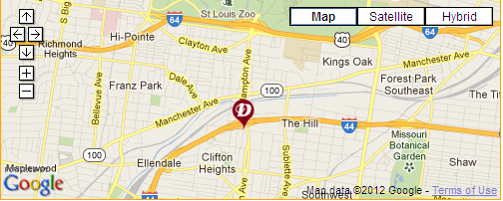

Directions:  Traveling East On I-44:  Take Exit #286  Turn Right On Hampton Ave  Turn Right On Wilson Ave  Turn Left On Sulphur Ave | Traveling West On I-44:  Take Exit #286  Turn Left On Hampton Ave  Turn Right On Wilson Ave  Turn Left On Sulphur Ave
The Extra’s Aren’t Extra at Drury Hotels! In addition to the great rate, here are some of the amenities our group will enjoy:

FREE HOT QUIKSTART ® Breakfast – At Drury, “hot” means Belgian waffles, scrambled
eggs, biscuits & gravy, sausage and more.

FREE 5:30 KICKBACK® - From 5:30-7:00 pm each evening, kick back, relax and enjoy a rotating menu of free hot food and cold beverages.

FREE Long Distance - One hour every room every night.

FREE Wireless Internet Access – High speed Internet in all rooms and the lobby.

FREE Soda and Popcorn – From 3:00 pm to 10:00 pm every night in the lobby.

Plus much more!!
HAABB 2017 Fall Meeting Registration Information
Registration Information:

There are two sessions available: Wednesday AM and Wednesday PM. The costs associated with each type of registration are as follows:

Individual: $60/session After 9/01/2017, each session price will increase to $65.

Institutional: $50 per attendee/session. Institutional membership cost is an additional $30.
After 09/01/2017, each session price will increase to $55.

CLS Student: $20/session After 09/01/2017, each session price will increase to $25.

HAABB Past President: $30/session After 09/01/2017, each session price will increase to $35

Methods of Registration:

Mail: Complete and mail the registration form along with payment to the following address. Make check payable to HAABB
Diana Moroney
844 Evergreen Forest Drive
Saint Peters, Mo 63376

Online: Register online at www.haabb.org to enter your registration information. You will be directed
to a PayPal page to make payment via credit card.
Registration Form Instructions: The form is divided into two sections: individual attendee, institutions requesting to send multiple attendees, and student attendee. Below describes each section.

Individual/Student Attendees Section: This section is for the individual or student seeking to attend the meeting. HAABB individual membership is included in the price of the sessions. By attending, membership is obtained. Membership will begin upon receipt of payment and will expire April 1, 2018. This section should also be used for CLS students wishing to attend the meeting at a discounted student session rate.

Institutional Attendees Section: This section is for institutions seeking to have multiple employees attend at a discounted session rate. HAABB institutional membership cost is $30. There is no limit to the number of employees that may attend when an institutional membership is obtained. The session fee must be paid per person per session attended. Membership will begin upon receipt of payment and will expire April 1, 2018.

Note: If you need to cancel your registration, please send an email to Diana Moroney, HAABB Treasurer, Diana.Moroney@redcross.org by 9/08/2017 to receive a full refund. After 09/08/2017, the registration fee is non-refundable.

MEETING DETAILS:
Lunch: All registrants are invited to enjoy lunch compliments of the HAABB Board of Directors! If you desire a VEGETARIAN lunch, please, check the box on the registration form.

Parking: Parking is free.

HAABB 2017 Fall Meeting Registration Form
Individual/Student Attendee Information

Name: ______________________________________________________

Institution: ______________________________________________________

Institution City/State: ______________________________________________________

Email*: ___________________________ Phone: ___________________________
*Email address provided will be used by HAABB for communication regarding meetings and may be shared with vendor exhibitors.

Check the sessions you will be attending: □ AM □ PM
VEGETARIAN LUNCH □ (please check if needed)

INDIVIDUAL: Total Cost = $60 ($65 after 9/1/2017) x # of Sessions = $_________
STUDENT: Total Cost = $20 ($25 after 9/1/2017) x # of Sessions = $_________
HAABB PAST PRESIDENT: Total Cost = $30 ($35 after 9/1/2017) x # of Sessions = $_________

Institutional Membership Attendee Information

Institution Name: ____________________________________________________________________

Institution City/State: ______________________________________________________

Institution Contact: _______________________________ E-mail*: ________________________
*Email address provided will be used by HAABB for communication regarding meetings and may be shared with vendor exhibitors.

In the space provided, please include the attendee names and which sessions will be attended. If additional space is needed, please attach a separate sheet. There is no limit to the number of attendees that can register when an institutional membership is obtained. Two sessions are available. Each session price is $50 per attendee. The institutional membership cost is an additional $30. After 9/1/2017, each session price will increase to $55

Attendee Name: Email* Session(s) attending:

1. _________________________________________________________________ □ AM □ PM

2. _________________________________________________________________ □ AM □ PM

3. _________________________________________________________________ □ AM □ PM

4. _________________________________________________________________ □ AM □ PM

5. _________________________________________________________________ □ AM □ PM

An additional sheet may be added if you are sending more employees than can fit on the form
Please, indicate if any of the attendees requires a VEGETARIAN lunch (* by the name)
Cost of Institutional Membership = $30
Cost of Sessions = $50 ($55 after 9/1/2017) x # of Sessions = $___________
Total Cost = $30 + Cost of Sessions = $___________

