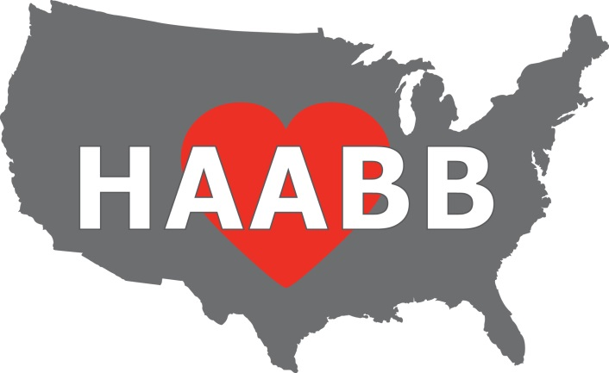

Heart of America
Association of Blood Banks

59th Annual Meeting

Tuesday & Wednesday

April 14 & 15, 2026

PRELIMINARY
PROGRAM

Argosy Casino, Hotel & Spa

777 NW Argosy Casino Pkwy

Riverside, MO 64150

Visit us
www.HAABB.org or find us on 

59th Spring Meeting Speaker Program

Tuesday, April 14, 2026
7:30 – 8:40 Registration located outside of the meeting rooms & breakfast in the Cordoba room

8:45 – 11:30 AM Session
- Patient Blood Management: Advancing Blood Utilization Strategies
  - Gagan Mathur, MD, MBA, UC Irvine
- From First Donation to Repeat: Do Rare Donor Welcome Packets Make a Difference?
  - Jennifer Jung, MLS(ASCP), SBB^{CM}, American Red Cross
- Building a Molecular Lab That Works: From Startup to Relocation
  - Jack Wilson, MLS(ASCP)^{CM}, Community Blood Center
- What hath the Europeans wrought? The potential elimination of CPDA-1
  - Eric Senaldi, MD, New York Blood Center Enterprises

11:30 – 1:00 Lunch and Opening of Vendor Exhibits

1:00 – 4:00 PM Session
- Presentation – TBD
  - Patty Eschliman, MHA, MLS(ASCP)^{CM}, DLM(ASCP)^{CM}CPC, North Kansas City Hospital
- A Colorful Solution to Battle FDA Reportable Events
  - Shay Jones, MLS(ASCP)^{CM}, BB^{CM}, The University of Kansas Health System
- Case Study – MARC, EMS/Lifeflight
  - Dr. Calloway Pichette, MD, HCA Research Hospital; KCFD; AMR Independence; Lee’s Summit Fire Department; Harrisonville Fire Department; Healthstar One
- Whole Blood Usage Panel
  - Carrie Easley, MSTM, MLS (ASCP) SBB^{CM}, Stormont Vail Health
  - David Harsh, Community Blood Center
  - Shay Jones MLS(ASCP)^{CM}, BB^{CM}, The University of Kansas Health System

4:00 – 6:00 Reception / Vendor Exhibits

Wednesday, April 15, 2026

7:30 – 8:35 Registration located outside of the meeting rooms & breakfast in the Cordoba room

8:35 – 11:30 AM Session
- Hospital Based Donor Recruitment
  - Carla Dzurko & David Harsh, North Kansas City Hospital & Community Blood Center
- Case Study: Donor Antibody Cases
  - Jennifer Jung, MLS(ASCP), SBB^{CM}, American Red Cross
- Case Study: Spill the Beans: A Tale of Polyagglutination
    - Abigail Logan, MLS(ASCP)^{CM}, Community Blood Center
- RH You Ready? Overview of a Blood Group System Through Cases
  - Lynsi Rahorst, MHPE, MLS(ASCP)SBB^{CM}, New York Blood Center Enterprises

11:30-1:00 Lunch and Vendor Exhibits

1:00 - 1:15 HAABB Annual Business Meeting

1:15 – 4:00 PM Session
- Unmasking A Rare RH Variant: Integrating Serology, Molecular Testing, and Family Studies In A Pregnant Congolese Patient
  - Andrea Pointer MLS, UHKC
  - Gina Folk, MSHS, MLS(ASCP)^{CM}, SBB^{CM}, Community Blood Center
- Presentation – TBD
  - Brian Easley, MHA, MLS(ASCP)^{CM}, SBB^{CM}, St. Luke’s Hospital
- Choose Your Own Adventure: Spring Cleaning – Sorting out Allo vs Autoantibodies
- Lynsi Rahorst, MHPE, MLS(ASCP)SBB^{CM}, New York Blood Center Enterprises
- Megan Dupont, MLS(ASCP), SBB^{CM}, Community Blood Center

2026 HAABB ANNUAL MEETING REGISTRATION
REGISTRATION INFORMATION

There are 4 sessions available: Tuesday AM, Tuesday PM, Wednesday AM and Wednesday PM. The costs associated with each type of registration are as follows:

Individual: $65 per session After 3/30/2026, each session price will increase to $70

Institutional: $60 per session The Institutional Membership cost is an additional $35.
After 3/30/2026, each session price will increase to $65

CLS Student: $25 per session After 3/30/2026, each session price will increase to $30

Resident: $50 per session After 3/30/2026, each session price will increase to $55
______________________________________________________________________________________________________

METHODS OF REGISTRATION:
Mail—Complete and mail the registration form including payment to the following address. Make check payable to HAABB. Brian Easley, HAABB Treasurer
5402 NW 93rd St.
Kansas City MO 64154
Online—Register online at www.haabb.org to make payment via credit card. ______________________________________________________________________________________________________

REGISTRATION FORM INSTRUCTIONS: The registration form is divided into two sections: individual/student/resident attendees and institutions requesting to send multiple attendees. Below describes each section.

Individual/Student/Resident Attendees Section: This section is for the individual or student seeking to attend the meeting. For the individual, HAABB individual membership is included in the price of the sessions. By attending, membership is obtained. Membership will begin upon receipt of payment and will expire April 1, 2027. This section should also be used for CLS students and Residents wishing to attend the meeting at a discounted student session rate.

Institutional Attendees Section: This section is for institutions seeking to have multiple employees attend the meeting at a discounted session rate. HAABB institutional membership cost is $35. There is no limit to the number of employees that may attend when an institutional membership is obtained. The session fee must be paid per person per session attended. Membership will begin upon receipt of payment and will expire April 1, 2027.

NOTE: If you need to cancel your registration, please send an email to Brian Easley, HAABB Treasurer, beasley@saint-lukes.org, by 3/30/2026, to receive a full refund. After 3/30/2026, the registration fee is non-refundable.
______________________________________________________________________________________________________

MEETING DETAILS:

Lunch:
All registrants are invited to enjoy lunch compliments of the HAABB Board of Directors! Lunch will be provided to the registrants on the day of the session(s) attended. If you desire a VEGETARIAN lunch, please check the box on the registration form.

Parking: Parking is Free.

2026 HAABB ANNUAL MEETING REGISTRATION
INDIVIDUAL / STUDENT / RESIDENT ATTENDEE INFORMATION

Attendee Name: __________________________________ Institution: ________________________________

Institution Address: ___________________________________________________________________________

Email*: __________________________________ Phone: ___________________________________________
*Email address provided will be used by HAABB for communication regarding meetings and may be shared with vendor exhibitors.

Check the sessions you will be attending: Wed AM Wed PM Thurs AM Thurs PM

VEGETARIAN LUNCH (please check if needed)

INDIVIDUAL: Total Cost = $65 ($70 after 3/30/2026) x # of Sessions = $________________
STUDENT: Total Cost = $25 ($30 after 3/30/2026) x # of Sessions = $________________
RESIDENT: Total Cost = $50 ($55 after 3/30/2026) x # of Sessions = $________________

INSTITUTIONAL MEMBERSHIP ATTENDEE INFORMATION

Institution Name: _________________________ Contact Person _______________________________________

Institution Address: ___________________________________________________________________________

Email*: ____________________________________ Phone: ________________________________________
*Email address provided will be used by HAABB for communication regarding meetings and may be shared with vendor exhibitors.

In the space provided, please include the attendee names, credentials, and which sessions will be attended. If additional space is needed, please attach a separate sheet. There is no limit to the number of attendees that can register when an institutional membership is obtained. Four sessions are available. Each session price is $60 per attendee. The institutional membership cost is an additional $35. After 3/30/2026, each session price will
increase to $65.

Attendee Name Credentials Tues AM Tues PM Wed AM Wed PM
1. ___________________________________________
2. ___________________________________________
3. ___________________________________________
4. ___________________________________________
5. ___________________________________________
Please indicate if any of the attendees requires a vegetarian lunch (* by the name)
Cost of Institutional Membership = $35
Cost of Sessions = $60 ($65 after 3/30/2026) x # of Sessions = $____________

Total Cost = $35 + Cost of Sessions = $___________
HOTEL RESERVATIONS

Argosy Casino, Hotel & Spa

777 NW Argosy Casino Pkwy

Riverside, MO 64150
https://www.argosykansascity.com

For reservations, go to Argosykansascity.com before 3/23/2026 to receive the applicable group rate of $109.99++ per night.
Click Book Now, Enter Group code: HA041326
Group name HAABB Annual Spring Meeting, click Select and complete the registration.

